Wired & wireless networking
Y12 - Cambridge International 9618 | 2.1.5 | Student booklet
Name: _______________________________ | Date: _____________

This booklet has everything you need for the lesson in one place. Work through it in order:
- Learn sections show the key slides. Read them carefully - they explain the ideas and show worked examples.
- Task sections are where you practise. Each task uses what the slides just before it taught you.
- Tasks get harder as you go and are written like Cambridge 9618 Paper 1 questions. Task 4 is extension or homework.
Do Task 1 from memory before you turn the page.
Task 1 Recall test - topologies and cloud [8 marks]
Closed book. 5 minutes.
1 Name the topology described. [3]
Description | Topology
Every device has its own link to a central switch
All devices share one cable with a terminator at each end
There are many routes between devices, so data can be re-routed

2 Define the term private cloud. [1]

3 A company stores its training courses on a public cloud. Describe two disadvantages of storing data on a public cloud compared to storing it on a server in the company's Local Area Network (LAN). [4]
9618/13 October/November 2023 Q3(a)(ii).

Learn Wireless networking
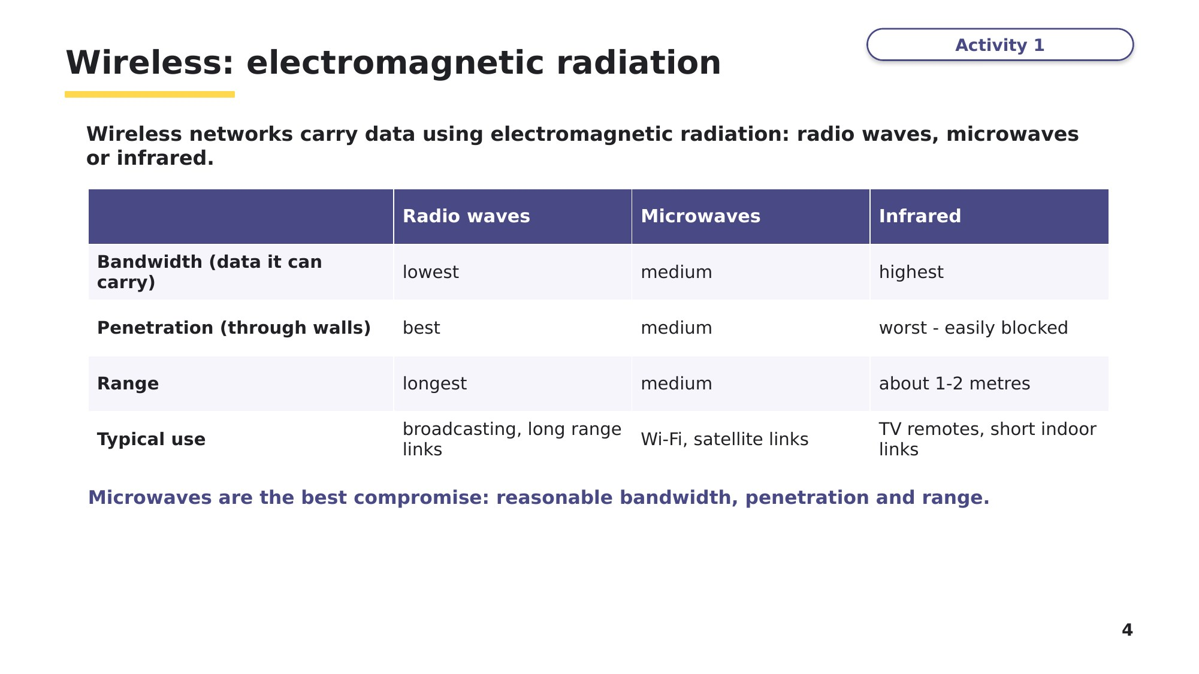
Slide 4 - Wireless: electromagnetic radiation
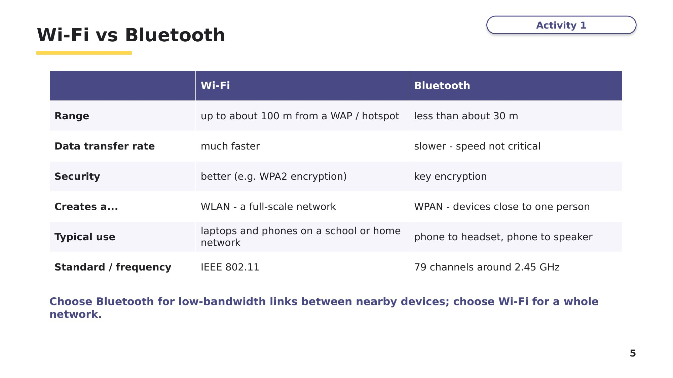
Slide 5 - Wi-Fi vs Bluetooth
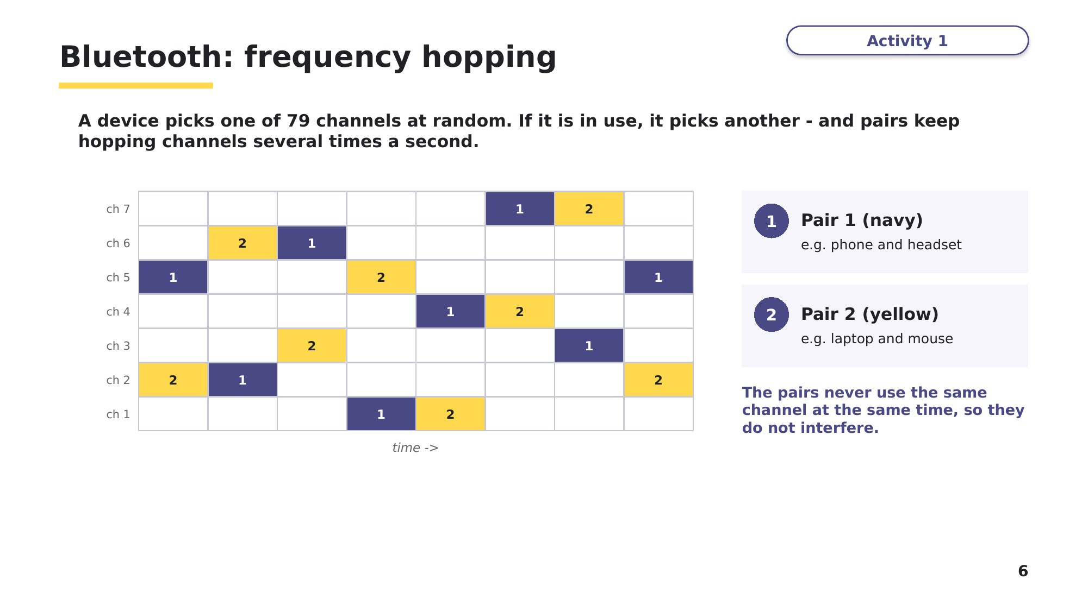
Slide 6 - Bluetooth: frequency hopping
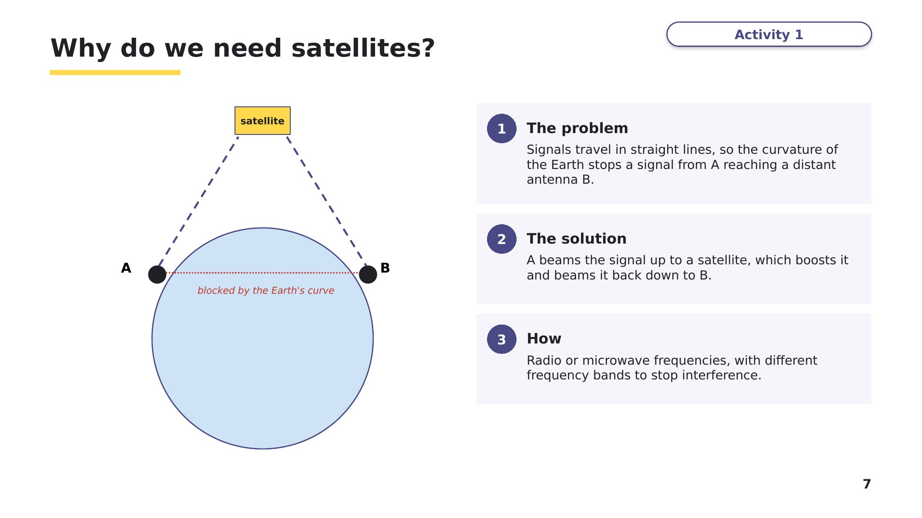
Slide 7 - Why do we need satellites?

Learn Wired networking
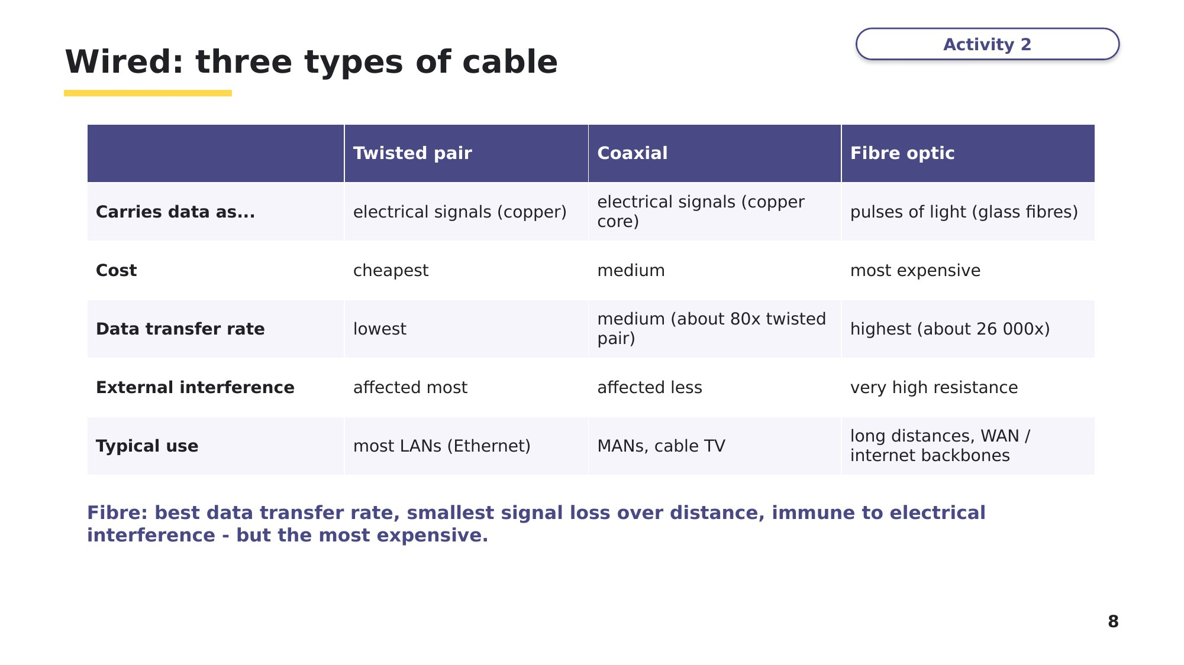
Slide 8 - Wired: three types of cable
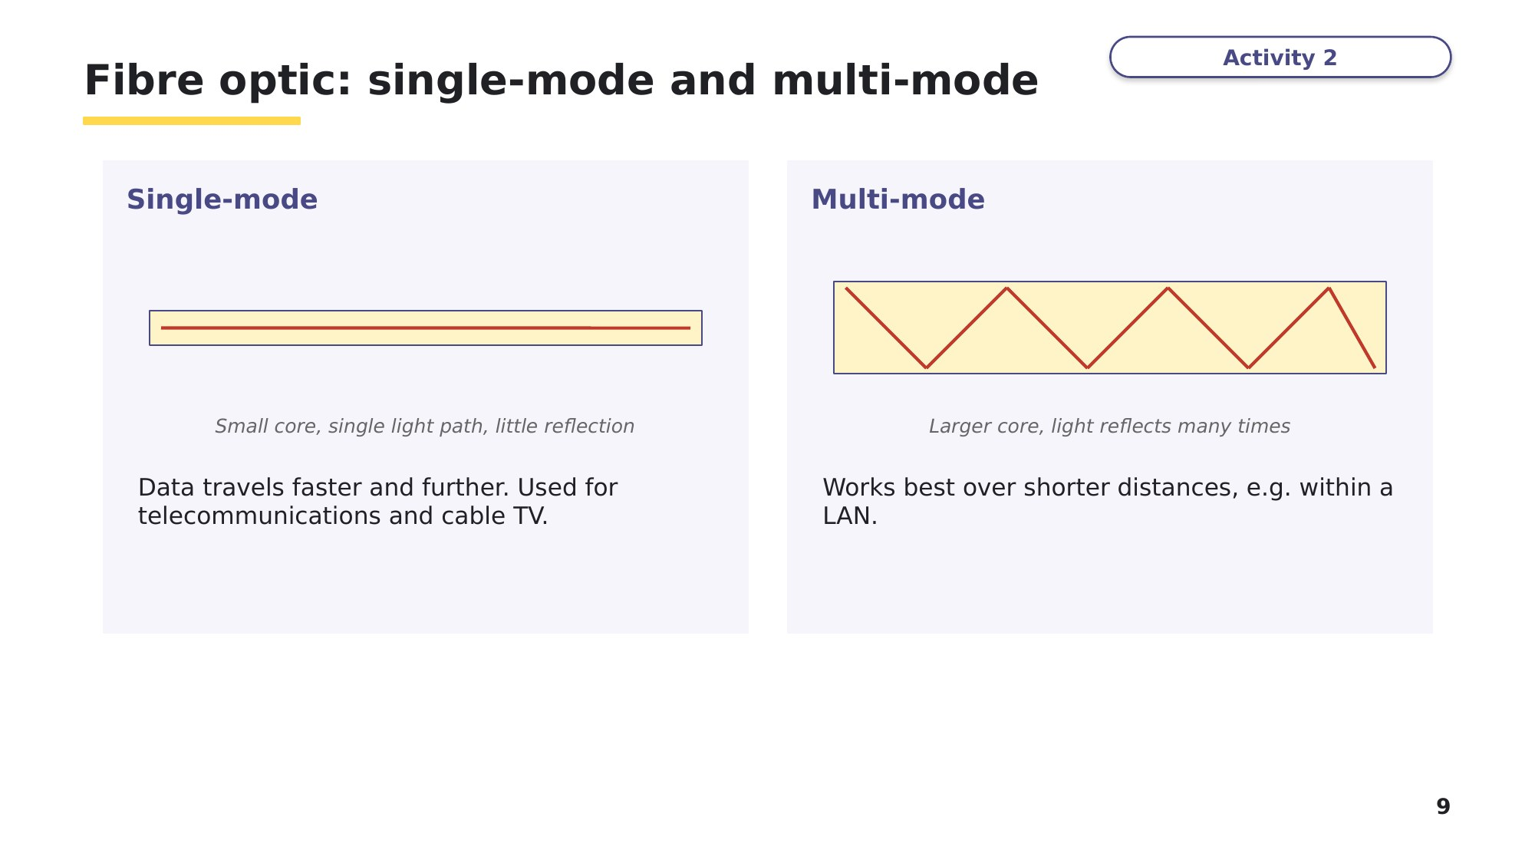
Slide 9 - Fibre optic: single-mode and multi-mode
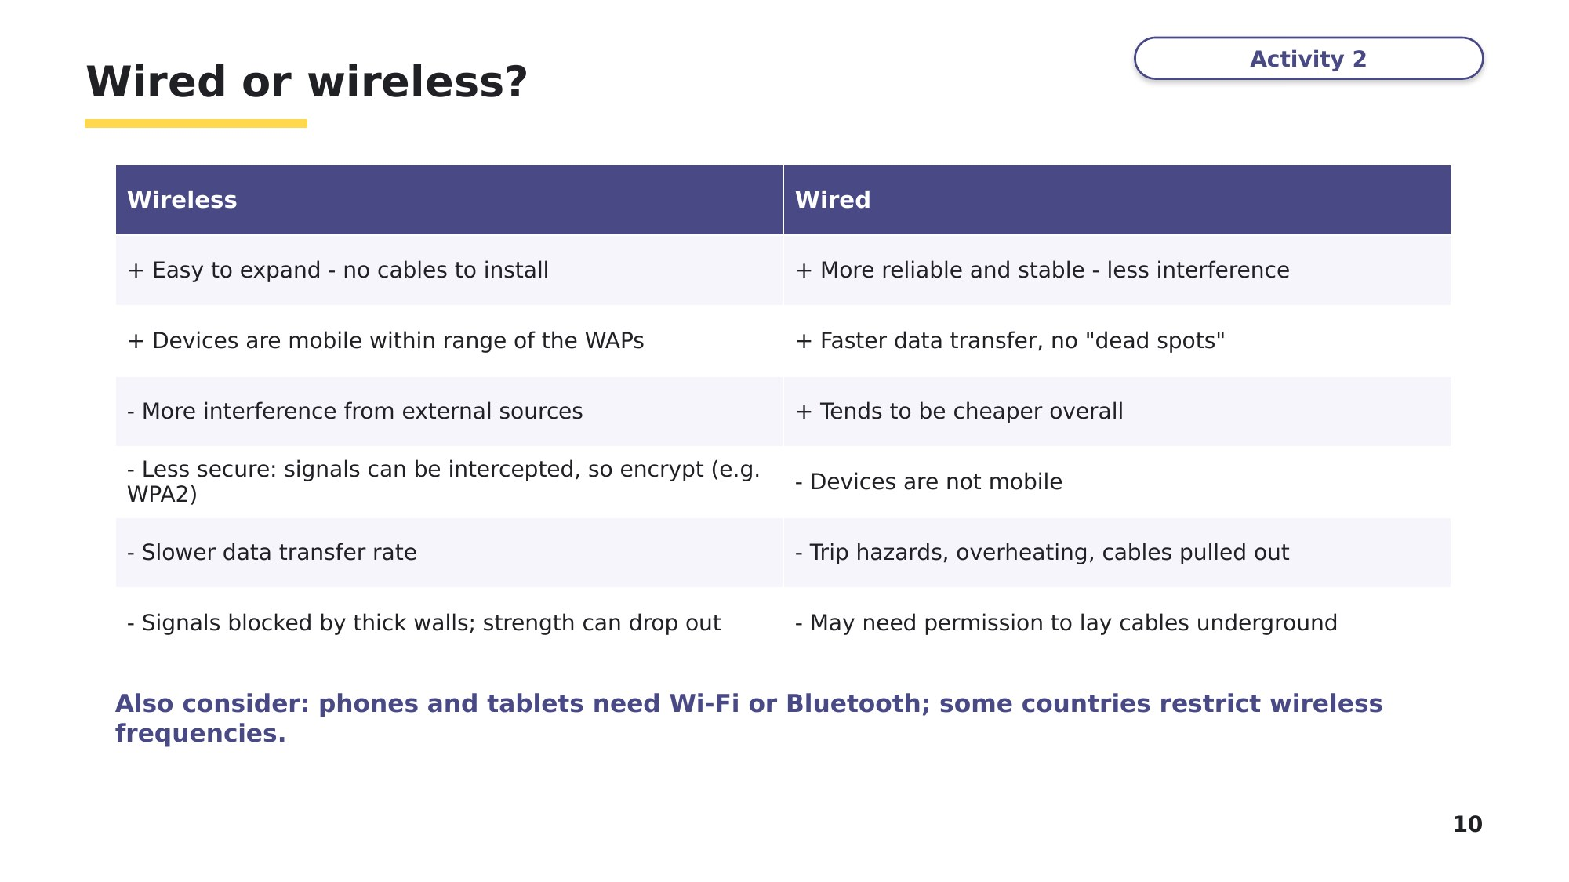
Slide 10 - Wired or wireless?
Task 2 Classify [6 marks]
(a) Tick one box in each row to show which cable each statement describes. [3]
Statement | Twisted pair | Coaxial | Fibre optic
Transmits data as pulses of light
The cheapest cable and the most common in LANs, but affected most by interference
Commonly used in MANs and by cable television companies

(b) Tick one box in each row to show whether the statement describes Wi-Fi or Bluetooth. [3]
Statement | Wi-Fi | Bluetooth
Connects devices less than about 30 metres apart to form a WPAN
Used to run a full-scale network through wireless access points up to 100 metres away
Picks one of 79 channels at random and keeps hopping between channels
Task 3 Exam-style questions [10 marks]
No recent 9618 Paper 1 question covers this exact content, so these are written in the same style.
(a) A school has two buildings 2 km apart. Explain why fibre-optic cable, rather than twisted pair cable, should be used to connect the networks in the two buildings. [2]

(b) A cafe wants to give its customers internet access. Give two advantages and one disadvantage of using a wireless network rather than a wired network. [3]

(c) Explain why a satellite is needed to send a microwave signal between two antennae on opposite sides of the world. [2]

(d) Describe how Bluetooth uses spread spectrum frequency hopping to reduce interference. [3]

Learn Exam technique
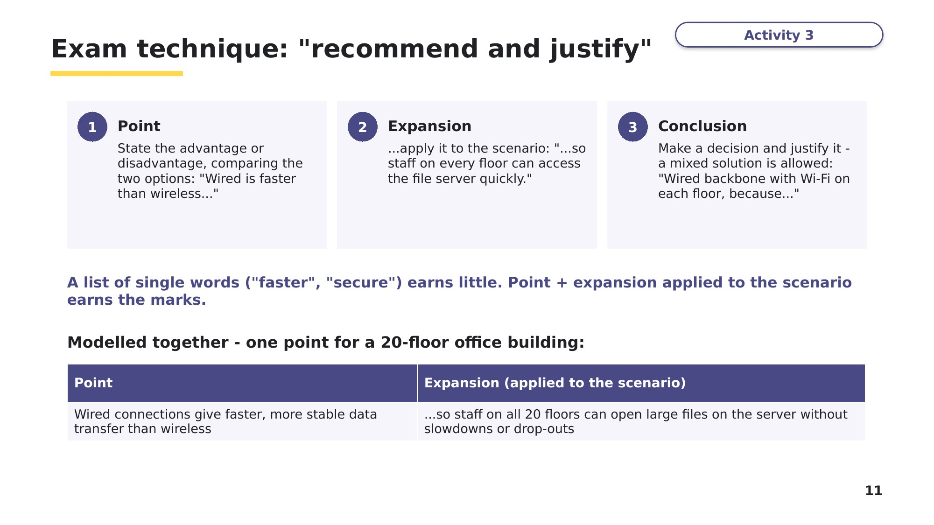
Slide 11 - Exam technique: recommend and justify
Task 4 Extension or homework [6 marks]
Textbook Activity 2B, question 4.
A manager has asked you to write a report on whether a LAN being set up in their new building should use wired or wireless connectivity. The building has 20 floors. Explain your arguments for and against both types of connectivity, and give a conclusion to help the manager decide. Use point + expansion for each argument.

Learn Review
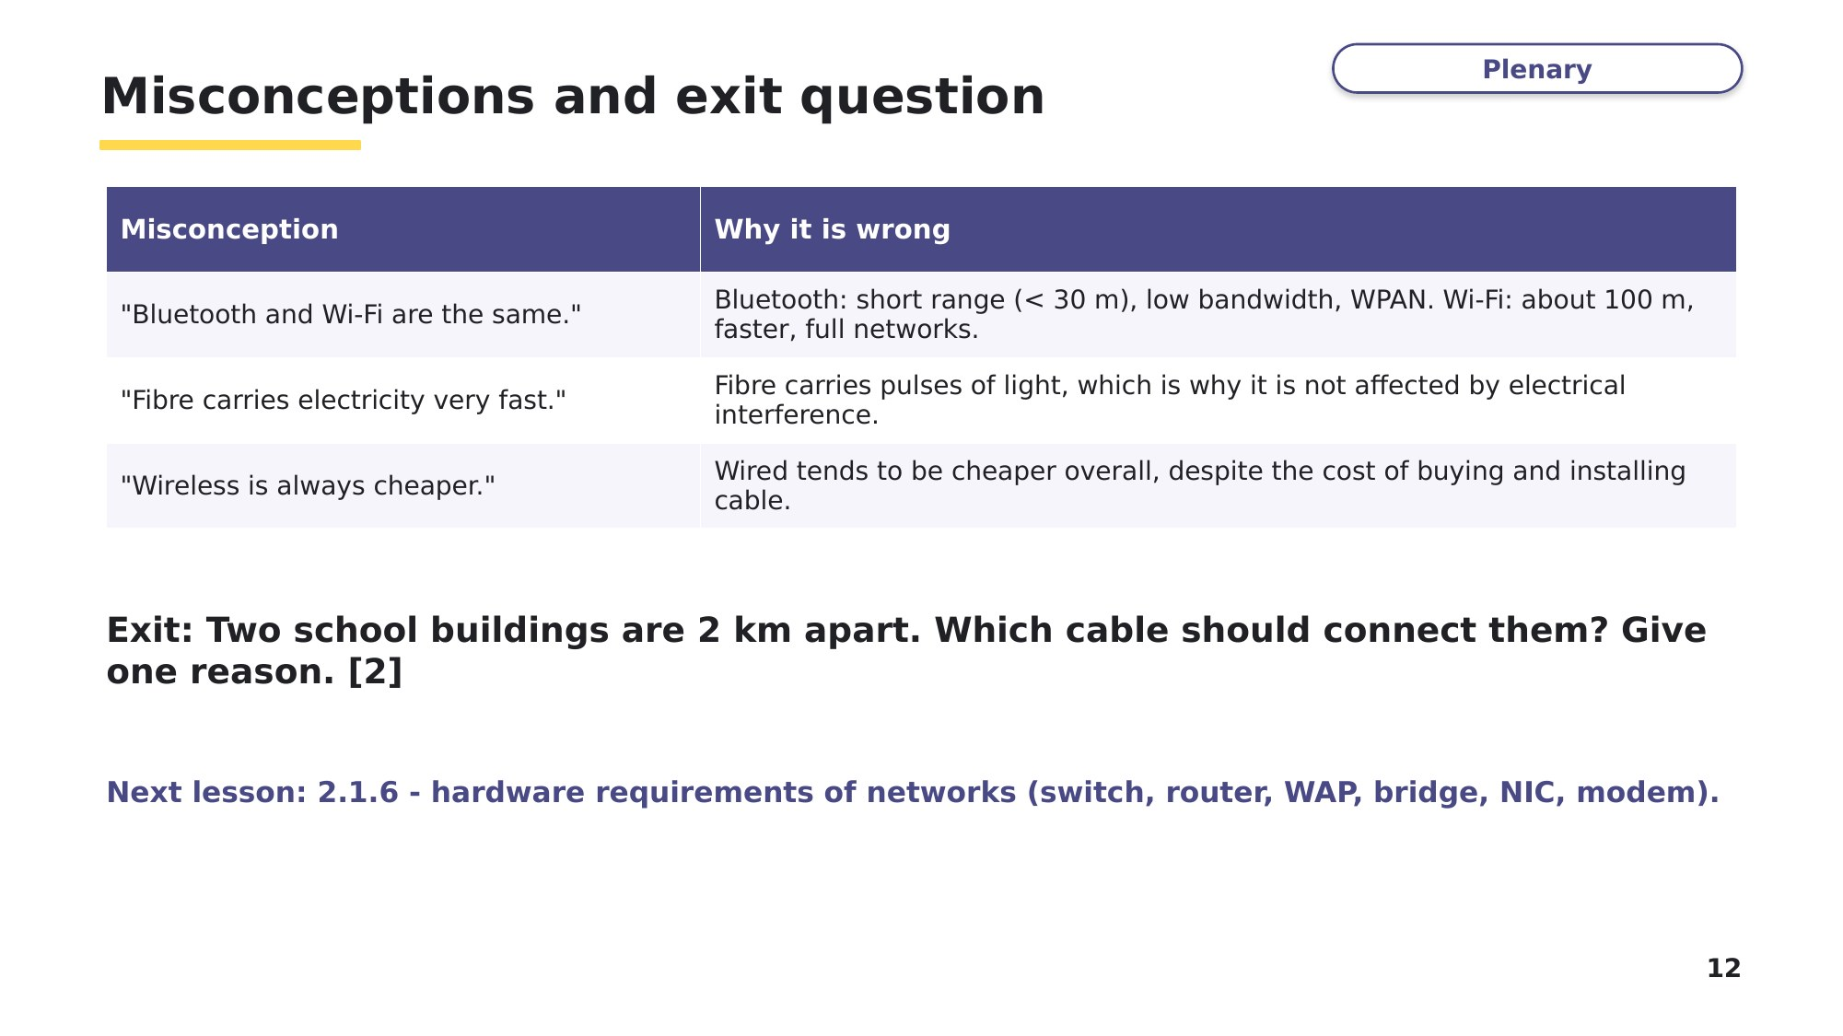
Slide 12 - Misconceptions and exit question

